We invite you
and your child with
congenital CMV to join the Colorado cCMV Family Network

What is Cytomegalovirus (CMV)?
Cytomegalovirus (CMV) is a common virus that infects people of all ages and is not harmful for most people. CMV spreads from person to person through body fluids, including saliva, urine, and blood. Many of us catch CMV as young children and the virus is prevalent in the saliva of toddlers. About 3 out of 4 adults have had CMV by age 40. Most of us will never even know we have had CMV.

What is Congenital CMV (cCMV)?
Sometimes a pregnant woman will pass CMV to her baby. When a baby is born with CMV infection, it is called congenital CMV (cCMV).
- 1 out of 200 babies is born with cCMV infection
- 3 out of 4 babies born with cCMV will never have any health issues
- About 1 out of 4 babies born with cCMV will have hearing loss at birth or develop hearing loss during the first few years of life
- Some babies born with cCMV will have other challenges besides hearing loss, including issues with seeing or development

What happens after your child receives a diagnosis of cCMV?
If your baby’s CMV test is positive, your pediatrician will talk with you about whether your baby needs additional testing or medication. Your baby may need to see other specialists to get the best treatment for cCMV (see graphic on second side).

If your baby is diagnosed with cCMV, where can you find support?
The Colorado cCMV Family Network can benefit your family in several ways. By joining, you can:
- Connect with other families who have children with cCMV
- Choose to meet with a Parent Guide who can share their CMV experience and resources
- Join a private Facebook group for Colorado families with cCMV
- Visit the National CMV Foundation, CDC, and AAP Colorado websites to learn more
- Learn more about cCMV so you can advocate for the best medical care for your child
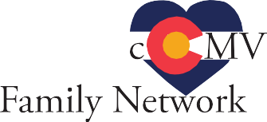
- Participate in building a unique community here in Colorado for children with cCMV

To join the Colorado cCMV Family Network, visit http://tiny.cc/COcCMVFamilyNetwork,
email: cCMV@co-hv.org or call 720-598-COHV (720-598-2648)

Grants to support the establishment of the Colorado cCMV Family Network have been provided by the American Academy of Pediatrics (AAP) and the Colorado Early Hearing Detection and Intervention (EHDI) Alliance. The Colorado cCMV Family Network is a collaboration with Colorado Hands & Voices, an organization for families raising children who are deaf or hard of hearing. The Colorado cCMV Family Network includes families who have kids with typical hearing.

“Having a child diagnosed with cCMV can be scary. There are so many unknowns and every child is affected differently. Having a support
system that understands the uncertainty is important.”

—Amber, parent
Colorado cCMV Family Network
National CMV Foundation
“Receiving our son’s congenital CMV diagnosis was unexpected and heartbreaking. Despite the
challenges that Matthew and we as a family face, he inspires us every
day, has taught us more than we could have ever
Infectious Disease (ID)
imagined, and is the biggest blessing.”
Ear Nose and Throat (ENT)
Opthalmology

—Erin, parent
Neurology

Parent Resources
Pediatric Audiology
Colorado Hands & Voices
Pediatric Specialists

“A diagnosis
Who’s in your circle?

“It’s ok to be

changes a lot
Speech Therapy
Sign Language Instructor
of things. Don’t ever let that define your life,
or your child’s life.
There is love and
life within and after a diagnosis.”

—Ashley, parent
Hearing Resources
Developmental Resources
broken and cry, and ask ‘why us?’ Finding support from families similar to mine
helped me remember that my child is who
Occupational Therapy (OT)
Physical Therapy (PT)
Child Find (Early Intervention Colorado)
he is supposed to be and he is perfect!”

—Jami, parent

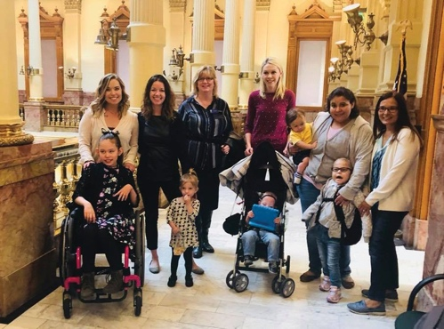
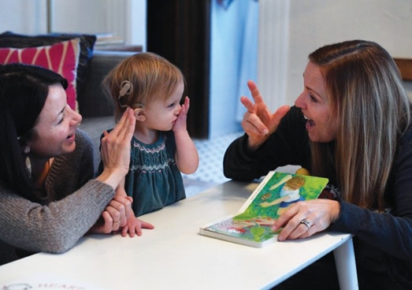
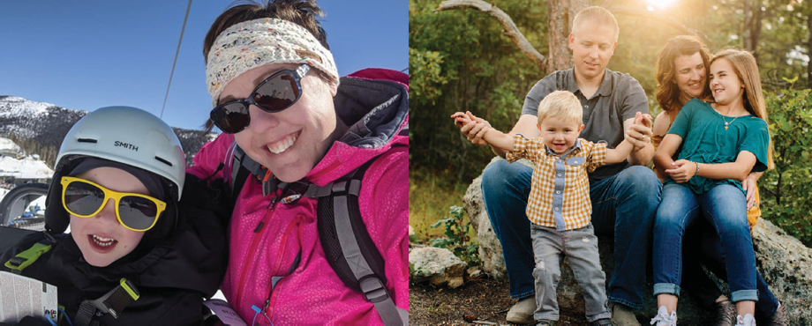

“If we don’t connect families to each other and to cCMV information, they can’t connect the dots about their children’s health. They need to find their tribe.” —Luke and Megan, parents
Your Child’s Pediatrician

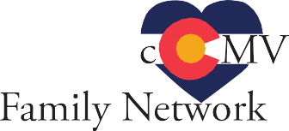
To join the Colorado cCMV Family Network:
Colorado Hearing Resource (CO-Hear)
- Visit http://tiny.cc/COcCMVFamilyNetwork
- Email cCMV@co-hv.org
- Call 720-598-COHV (720-598-2648)
- OR scan the QR code to the right

